EAS Oracle Apps
Lab Book

Copyright © 2011 IGATE Corporation. All rights reserved. No part of this publication shall be reproduced in any way, including but not limited to photocopy, photographic, magnetic, or other record, without the prior written permission of iGATE Corporation.


IGATE Corporation considers information included in this document to be Confidential and Proprietary.

Document Revision History

Date | Revision No. | Author | Summary of Changes
11-Aug-2011 | 1.0 | Amit Sali | Content Creation

Table of Contents
Document Revision History 2
Table of Contents 3
Getting Started 4
Overview 4
Setup Checklist for EAS Oracle Application 4
Instructions 4
Lab 1. Creating report and uploading report in Oracle Application server 5
1.1: Create a report 5
Lab 2. Registering report in Oracle Application 9
2.1: Registering report 9
Lab 3. Running report in Oracle Application 12
3.1: Run Report 12
Lab 4. Registration and Running a PL/SQL Program in Oracle Application 14
4.1: Registration and Running a PL/SQL Program in Oracle Application 14
Lab 5. Generating executable and uploading form in Oracle Application 16
5.1: Create a form using templet.fmb 16
5.2: Upload it to CUSTOM_TOP 18
Lab 6. Registering form in Oracle Application 22
6.1: Registering form 22
Appendices 25
Appendix A: Table of Figures 25
Appendix B: Table of Examples 25

Getting Started

Overview
This lab book is a guided tour for learning EAS oracle application. It comprises ‘To Do’ assignments. Follow the steps provided and work out the ‘To Do’ assignments.

Setup Checklist for EAS Oracle Application
Here is what is expected on your machine in order for the lab to work.
Minimum System Requirements
- Intel Pentium 90 or higher (P166 recommended)
- Microsoft Windows 95, 98, or NT 4.0, 2k, XP.
- Memory: 32MB of RAM (64MB or more recommended)
- Internet Explorer 6.0 or higher sas

Please ensure that the following is done:
- NA

Instructions

- For all coding standards refer Appendix A. All lab assignments should refer coding standards.
- Create a directory by your name in drive <drive>. In this directory, create a subdirectory <eas orapps>_assgn. For each lab exercise create a directory as lab <lab number>.

- Creating report and uploading report in Oracle Application server

Goals | - To create report and upload it in Oracle Application server
Time

1.1: Create a report
Solution:
Step 1: Start Report Builder Open reports6i Application, by selecting
Start → Programs → Oracle Reports 6i – OraHome62 → Report Builder.

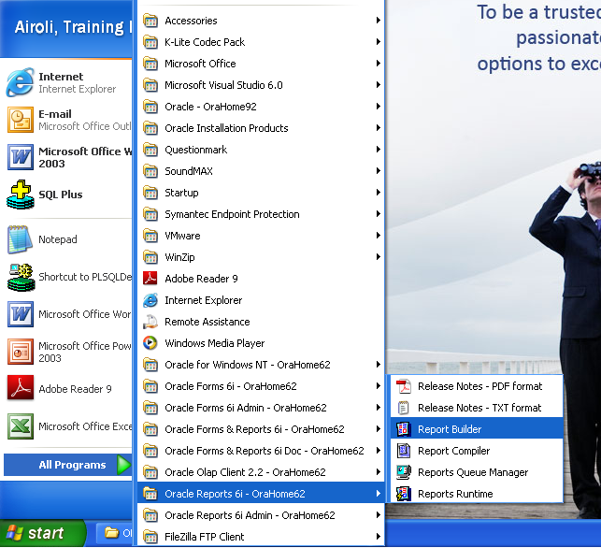

Figure 1: Start Report Builder

Step 2: Develop the report as per requirement. Save this form in a proper location.

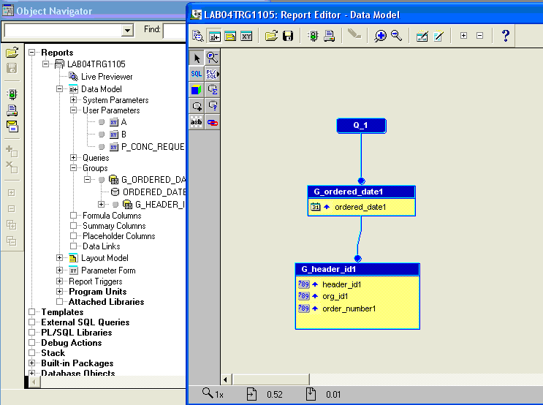

Figure 2: Design the report

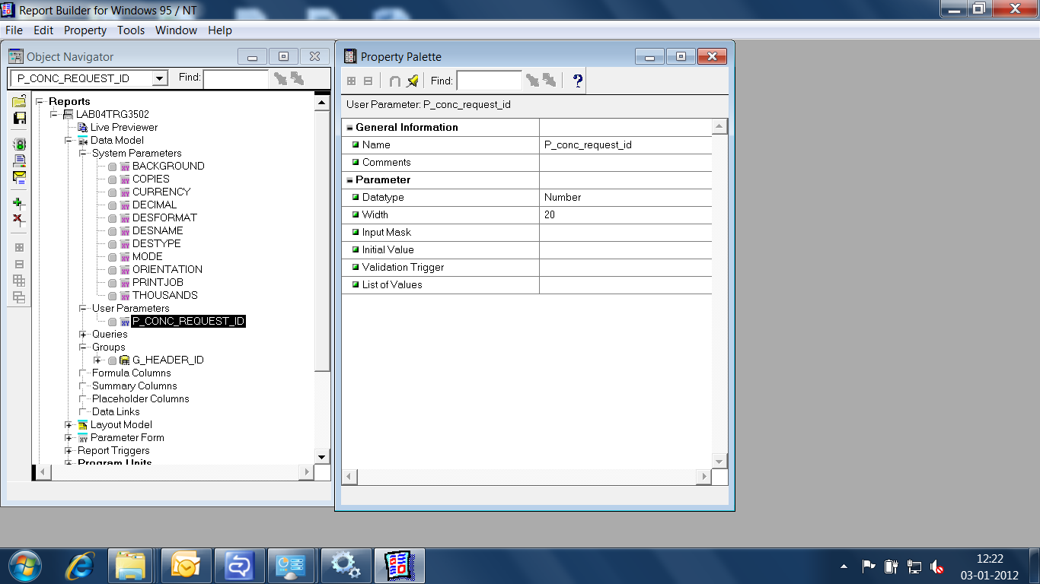

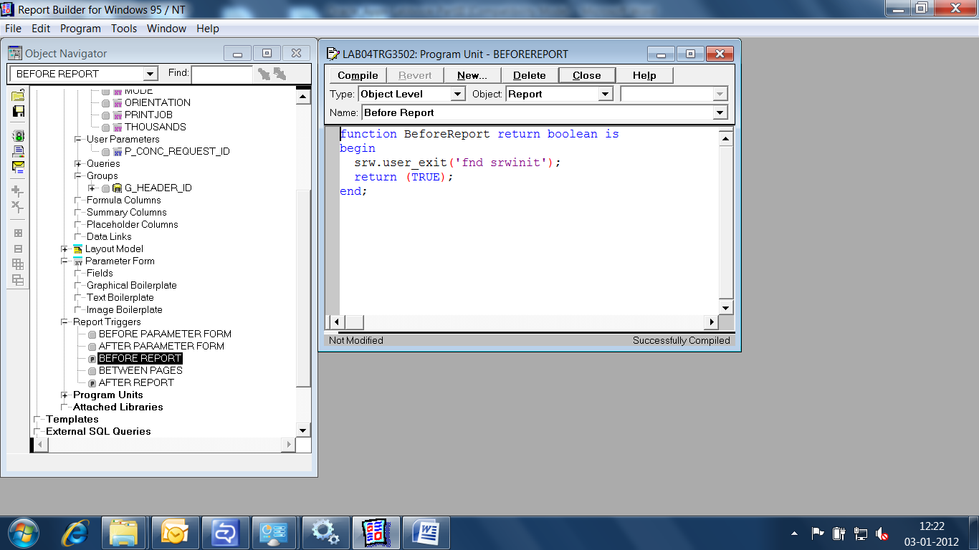

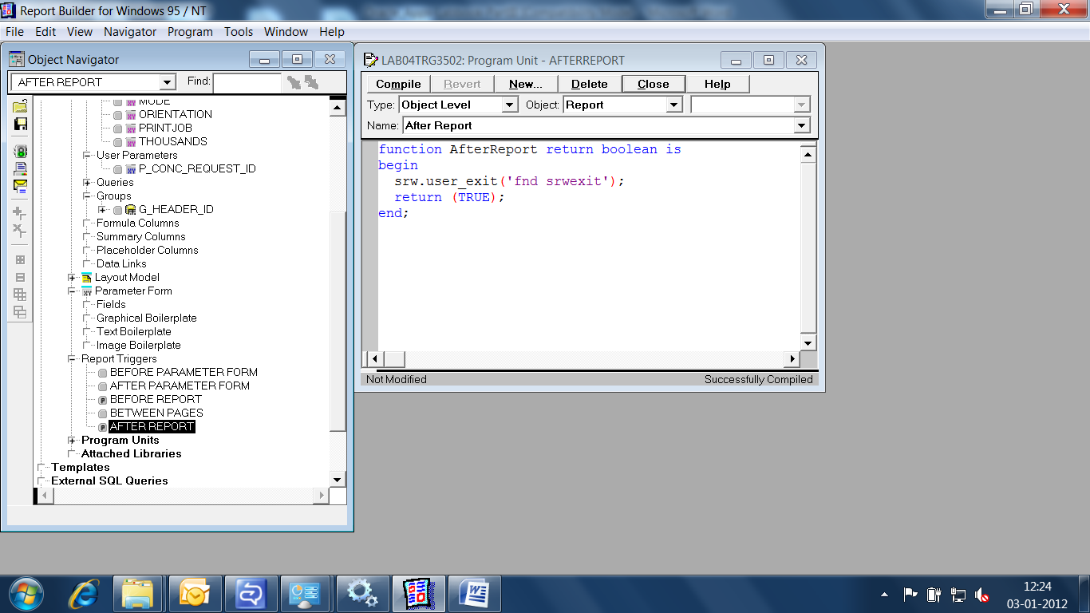

Step 3: Upload the file to CUSTOM_TOP
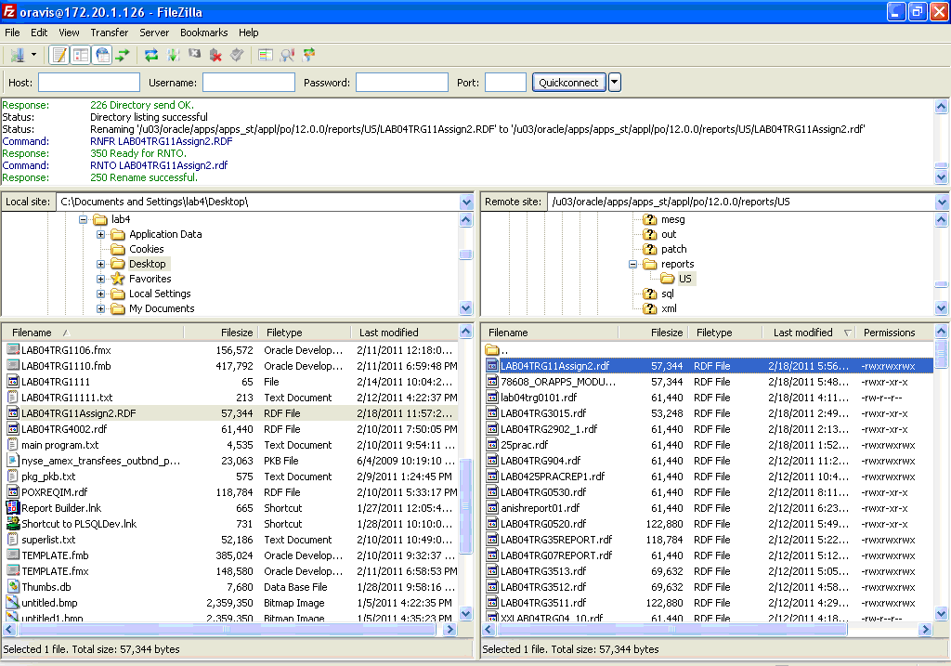

Figure 3: Upload the report on custom top
- Registering report in Oracle Application

Goals | - To register report in Oracle Application.
Time

2.1: Registering report
Solution:

Step 1: Now Login to Oracle Application.
Go to Responsibility “Application developer”→Concurrent→Program
Register an executable in oracle applications, as follows
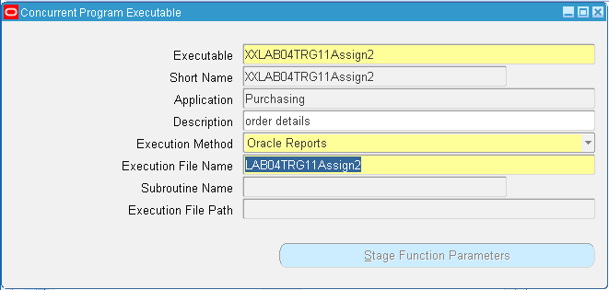
Figure 4: Executable Registration

Step 2: Make a program and attach executable
Go to Responsibility “Application developer”→Concurrent→Executable
Fill the details and save.

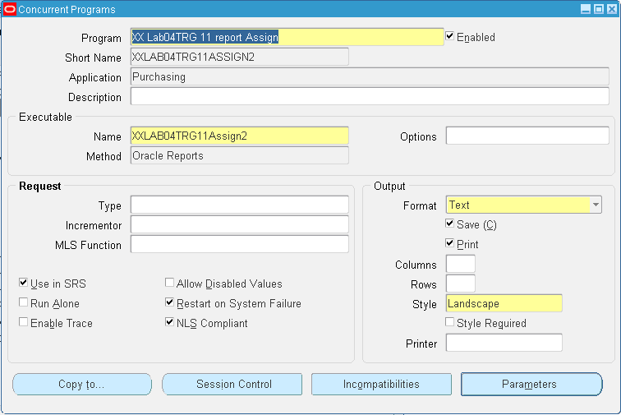

Figure 5: Program Registration

Step 3: Click on parameter Button
Create parameter and give the respective parameter in token field
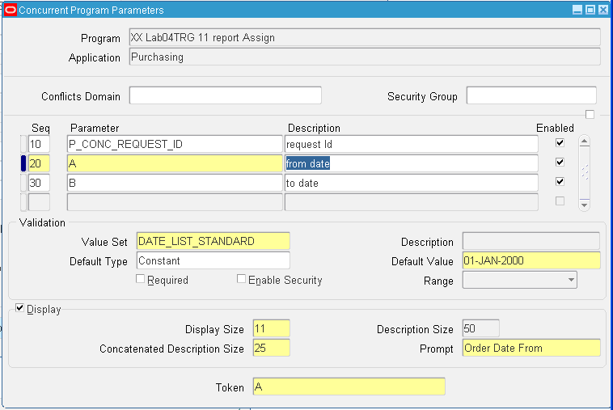
Figure 6: Parameter Registration
Step 4: Attach the program name to a responsibility
Go to Responsibility “System Administrator”→Security→Responsibility→ Request
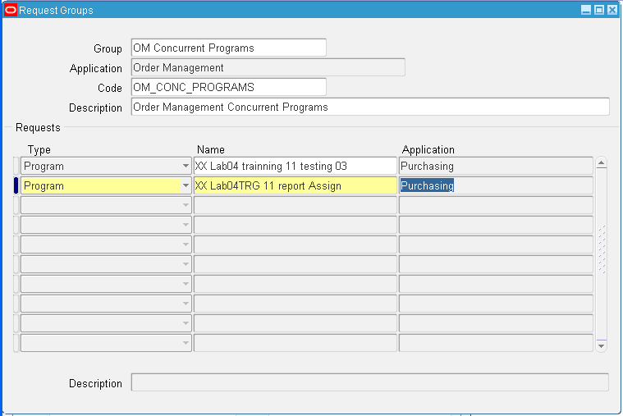

Figure 7: Attaching program to request group

- Running report in Oracle Application

Goals | - To run report in Oracle Application
Time

3.1: Run Report
Solution:
Step 1: Now Login to Oracle Application.
Run a request
Go to Respective Responsibility →(M) view → submit a new request
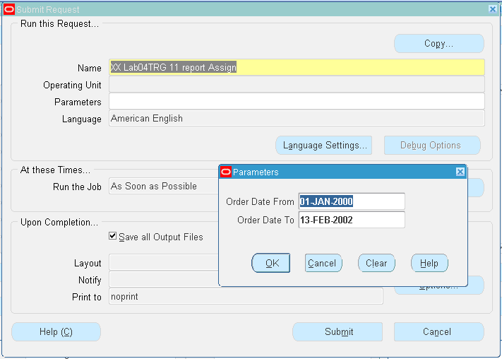

Figure 8: Running a program

Step 2:
Give the parameter and submit request and find the request id and see the output

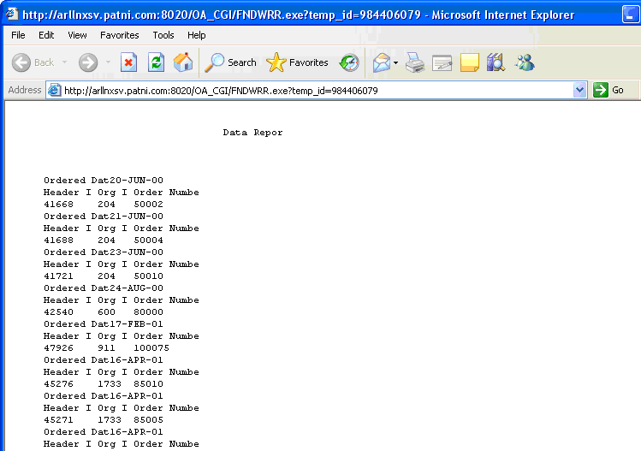

Figure 9: Output of the report

- Registration and Running a PL/SQL Program in Oracle Application

Goals | - To run report in Oracle Application. Registration and Running a PL/SQL Program in Oracle Application
Time

4.1: Registration and Running a PL/SQL Program in Oracle Application
Solution:
Step 1: Login to the Oracle Apps Database. And compile the package mention below
CODING

CREATE OR REPLACE PACKAGE lab04test_pkg
AS
PROCEDURE lab04training (
errbuf OUT VARCHAR2,
retcode OUT NUMBER) ;

END lab04test_pkg;
/

CREATE OR REPLACE PACKAGE BODY lab04test_pkg
AS
PROCEDURE lab04training (
errbuf OUT VARCHAR2,
retcode OUT NUMBER)
AS

BEGIN
fnd_file.put_line (fnd_file.output,
'in output file' );
fnd_file.put_line (fnd_file.log, 'in log file');

END lab04training;
END lab04test_pkg;
/

Example 1: Sample Code

Step 2:
Make a program and attach executable
Now Login to Oracle Application.
Go to Responsibility “Application developer”→Concurrent→Executable
Fill the details and save.
Register an executable in oracle applications, as follows

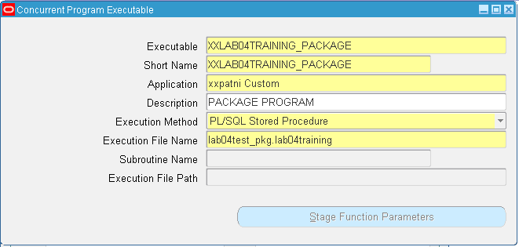

Figure 10: Executable Registration

Step 3:
Now Follow lab 2 (Steps 2 to 4), and to run the program follow steps mention in Lab 3 and see/analyze output.

- Generating executable and uploading form in Oracle Application

Goals | - To generate executable and upload form in Oracle Application
Time

5.1: Create a form using templet.fmb
Solution:
Step 1: Creating form:
Open form 6i Application, by selecting Start → Programs → Oracle Forms 6i – OraHome → Form Builder.
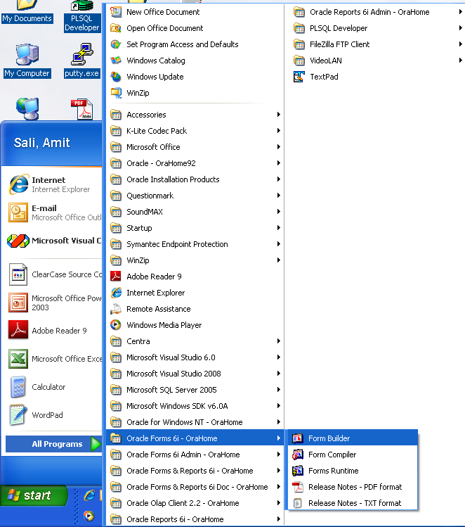
Figure 11: All Programs menu
Step 2: In forms builder, open the template form:
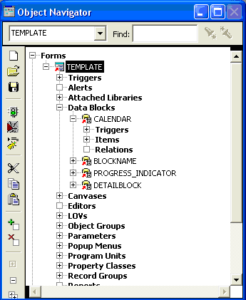
Figure 12: Creating from using template.fmb

Step 3: In the template form, change the layout as per your requirements. Save this form in a proper location.

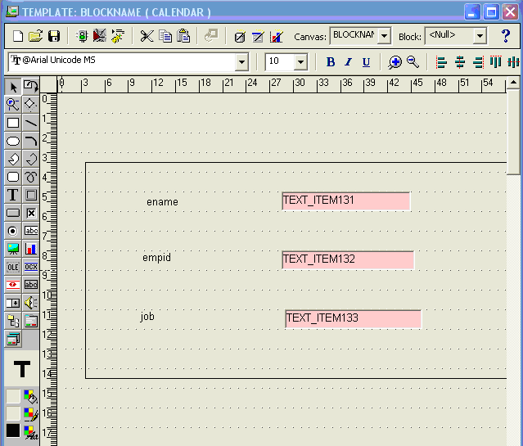

Figure 13: Sample Form

5.2: Upload it to CUSTOM_TOP
Solution:
Step 1: Open FILEZILLA and login and go to the au top-forms.
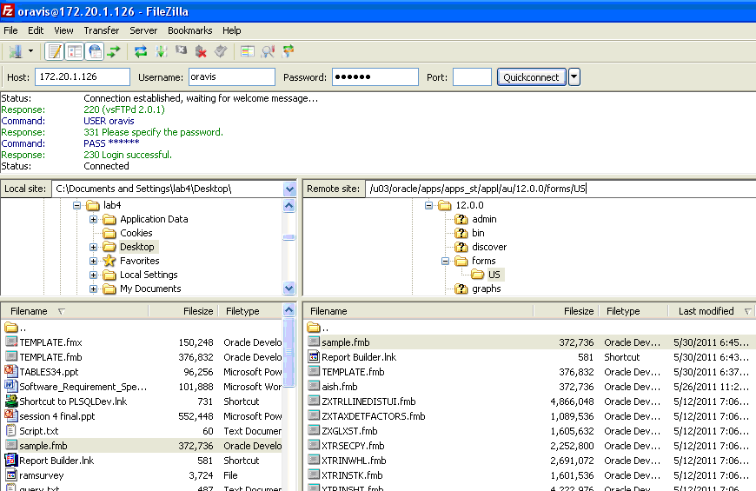
Figure 14: Form Upload step 1

Step 2: Upload the file to AU_TOP and Set the file permission to 755.
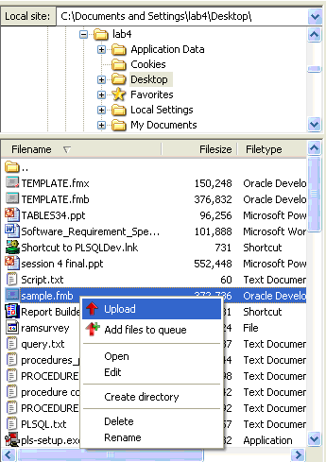

Figure 15: Form Upload step 2
Step 3: Change the file permissions for that form. Give it as 755.
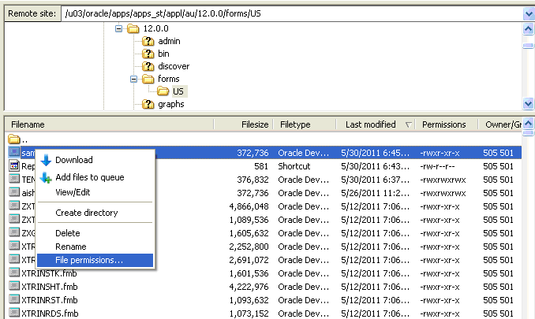
Figure 16: Form Upload step 3

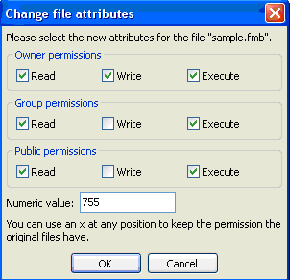

Figure 17: Supplying 755 Permission

Step 4: Compile and generate executable file of the form using command below

Step 5: Now open PUTTY and give the command to link the form with ORAPPS.
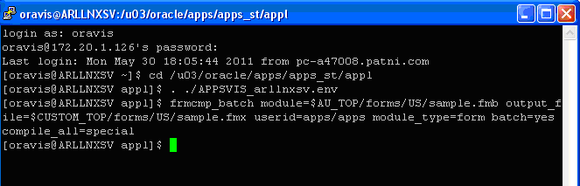

Figure 18: Generating executable of fmb

Step 6: Download the .fmx file from xxpatni custom and upload it in ONT_TOP.
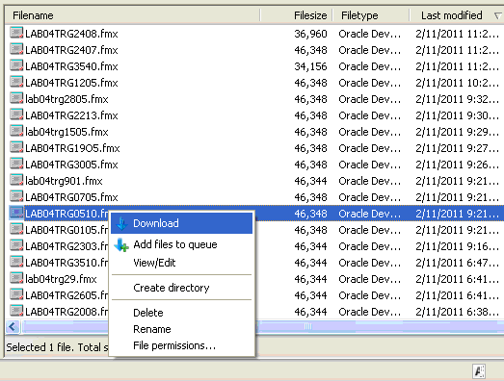

Figure 19: Downloading form
- Registering form in Oracle Application

Goals | - To register form in Oracle Application
Time

6.1: Registering form
Solution:
Step 1: Now Login to ORAPPS.
Go to application developer→application→forms
Fill the details in this screen and save.

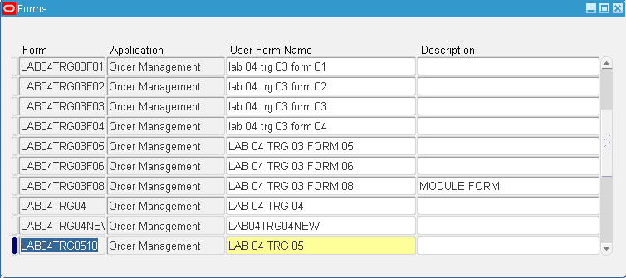

Figure 20: Registering a form

Step 2: Application→ Function →Description
Fill the details and save.

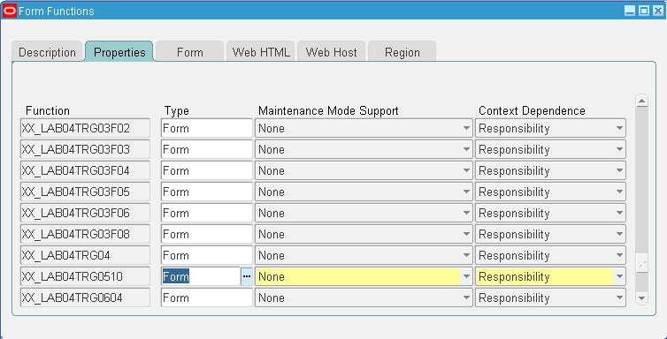
.
Figure 21: Providing details of properties

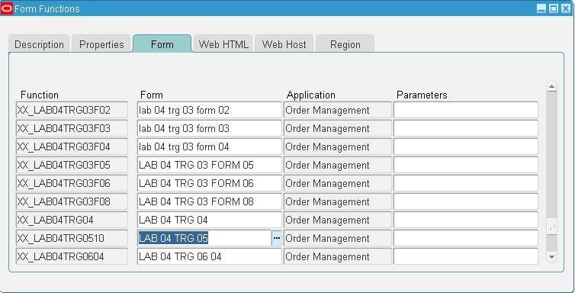

Figure 22: Providing details of function

Step 3: Application→ Menu

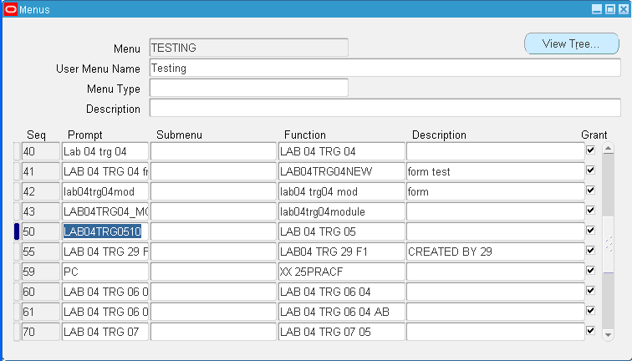
Figure 23: Attaching form to menu

Appendices

Appendix A: Table of Figures

Figure 1: Start Report Builder 5
Figure 2: Design the report 6
Figure 3: Upload the report on custom top 8
Figure 4: Executable Registration 9
Figure 5: Program Registration 10
Figure 6: Parameter Registration 10
Figure 7: Attaching program to request group 11
Figure 8: Running a program 12
Figure 9: Output of the report 13
Figure 10: Executable Registration 15
Figure 11: All Programs menu 16
Figure 12: Creating from using template.fmb 17
Figure 13: Sample Form 18
Figure 14: Form Upload step 1 19
Figure 15: Form Upload step 2 19
Figure 16: Form Upload step 3 20
Figure 17: Supplying 755 Permission 20
Figure 18: Generating executable of fmb 21
Figure 19: Downloading form 21
Figure 20: Registering a form 22
Figure 21: Providing details of properties 23
Figure 22: Providing details of function 23
Figure 23: Attaching form to menu 24

Appendix B: Table of Examples
Example 1: Sample Code 14

